Ainshams university
Faculty of engineering
Mechatronics and automation

Industrial Robotics milestone
MCT344

Team 16

Made by :
Ebrahim Abdelghfar Ebrahim 18p8600
Hesham Hesham mohamed 18p2187
Amr Balegh Hamdy 18P2301

Screenshots:

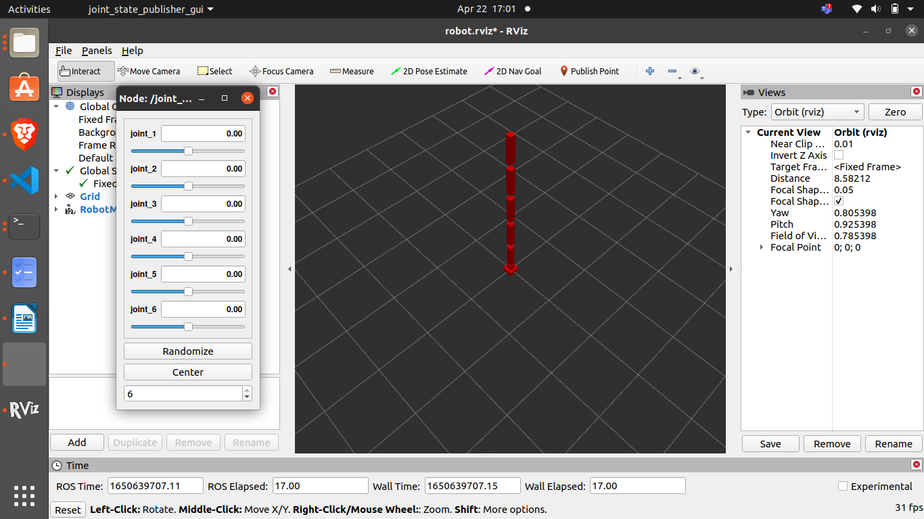
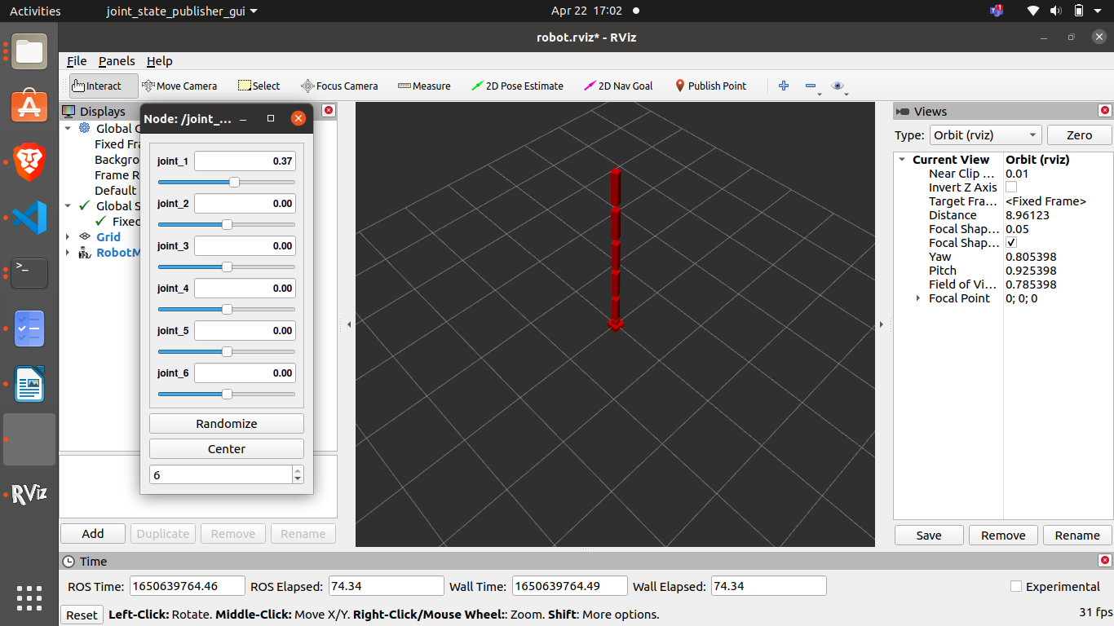
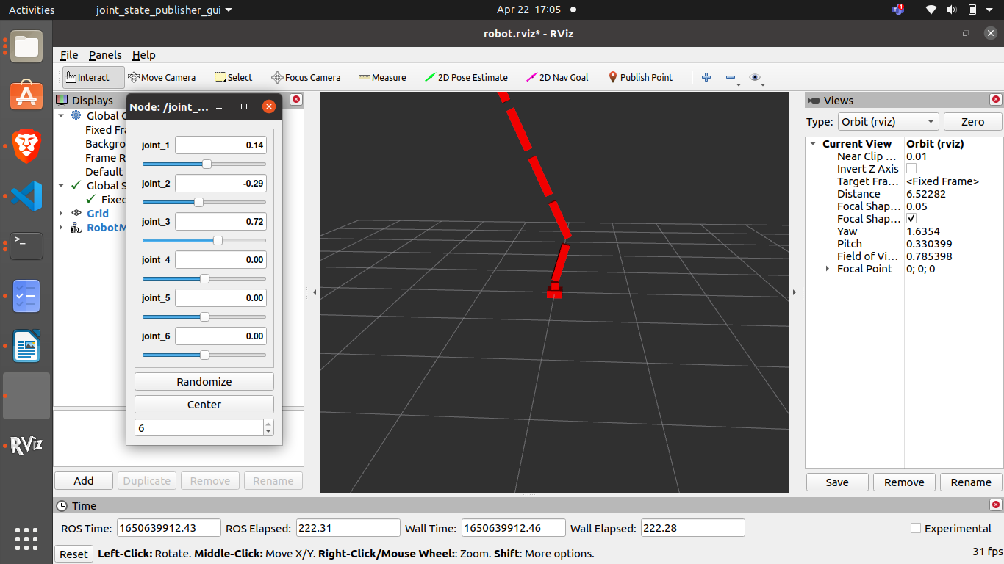

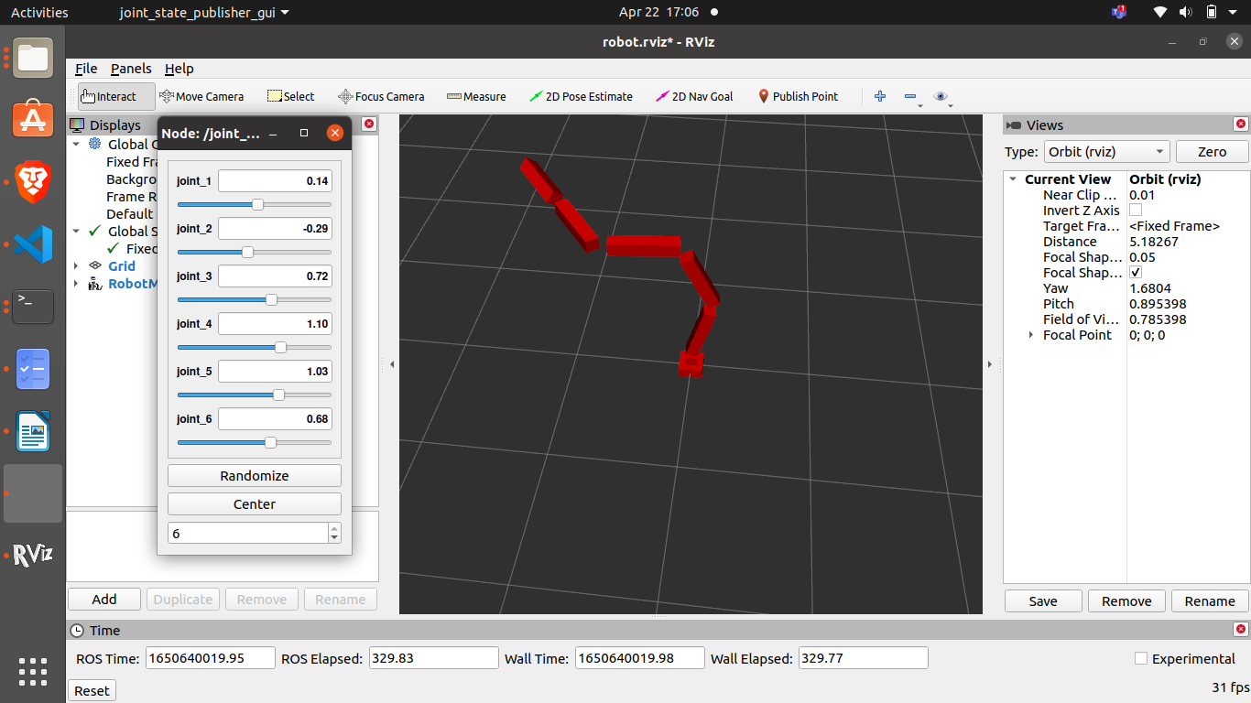
package link: https://drive.google.com/drive/folders/11-8PQPIXquRbiejwMFRUqPIYj-1UvH-4?usp=sharing

